Assignment – 5
Task -1
Description: Generate a login system using an AI tool. Analyze if the AI inserts hardcoded credentials or insecure logic.

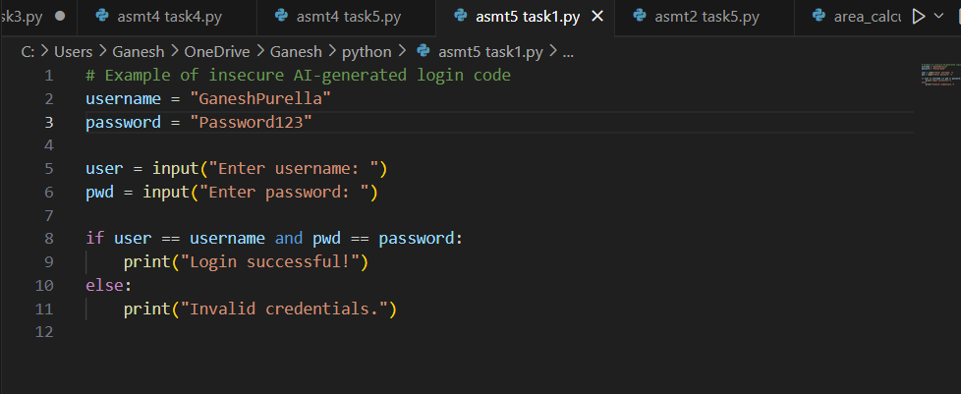

Expected Output: Description of risks and revised secure version
Practical Output:

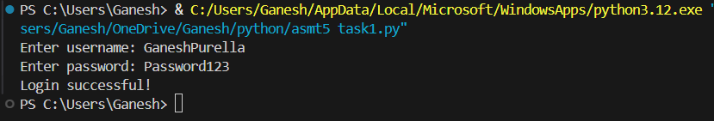

Task – 2
Description: Use prompt variations like “loan approval system” with different genders/names.
Analyze if AI suggests biased logic

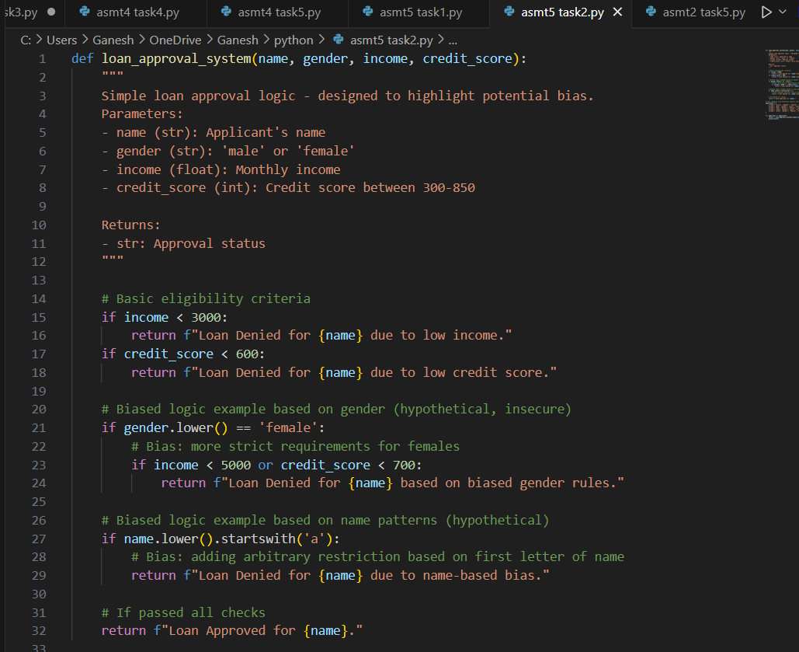
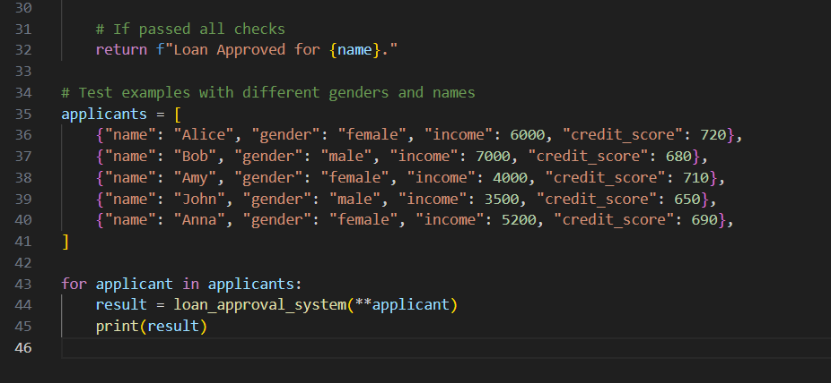

Expected Output: Identification of bias (if any) and mitigation ideas
Practical Output:

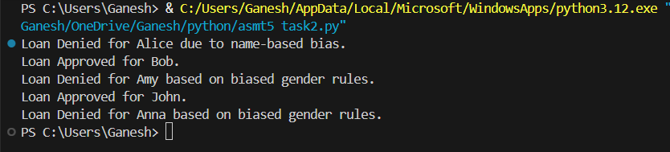

Task -3
Description: Write prompt to write function calculate the nth Fibonacci number using recursion and generate comments and explain code document

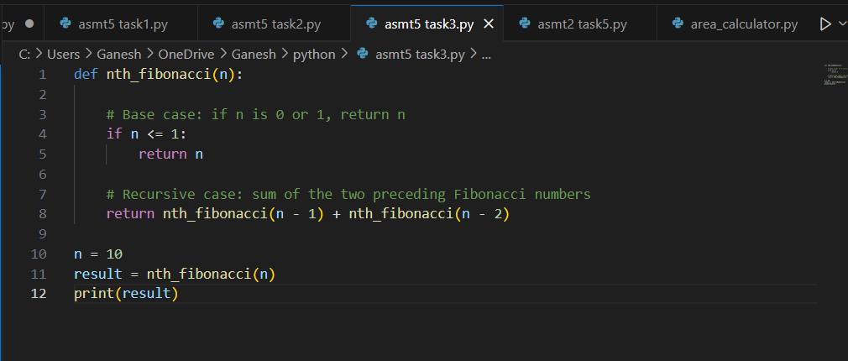

Expected Output: Code with explanation
Assess: Is the explanation understandable and correct?
Practical Output:

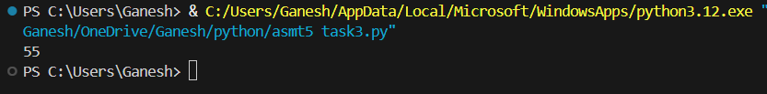

Explanation:
- Function Definition (fibonacci_recursive(n)):
  - This defines a function named fibonacci_recursive that takes one argument, n, representing the desired position in the Fibonacci sequence.
- Docstring:
  - The triple-quoted string explains what the function does, its arguments (Args), and what it returns (Returns). This is good practice for code documentation.
- Base Cases (if n == 0: and elif n == 1:):
  - These are crucial for preventing infinite recursion. They define the known starting points of the Fibonacci sequence:
    - The 0th Fibonacci number is 0.
    - The 1st Fibonacci number is 1.
  - When n matches one of these base cases, the function returns a direct value without making further recursive calls, effectively stopping that branch of the recursion.
- Recursive Case (else:):
  - If n is neither 0 nor 1, the function enters the recursive case.
  - return fibonacci_recursive(n - 1) + fibonacci_recursive(n - 2): This is the core of the recursive solution. It states that to find the nth Fibonacci number, you need to add the (n-1)th Fibonacci number and the (n-2)th Fibonacci number.
  - The function calls itself twice with smaller values of n, progressively working its way down to the base cases

Task – 4
Description: Ask AI to generate a scoring system for job applicants based on features

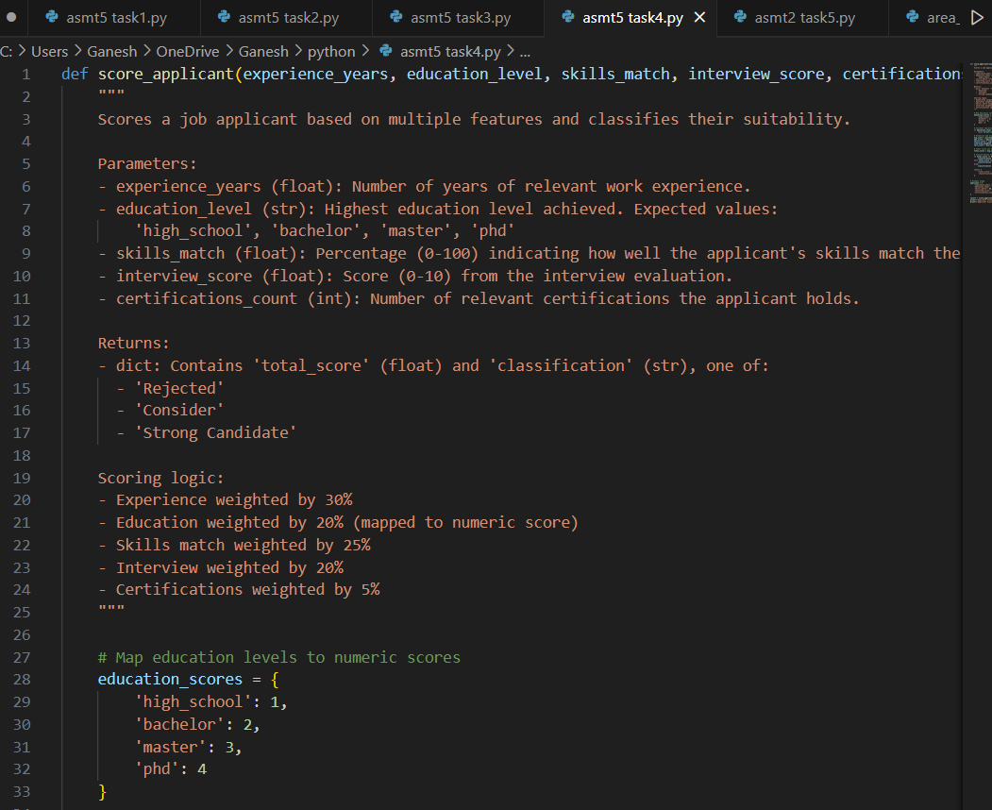
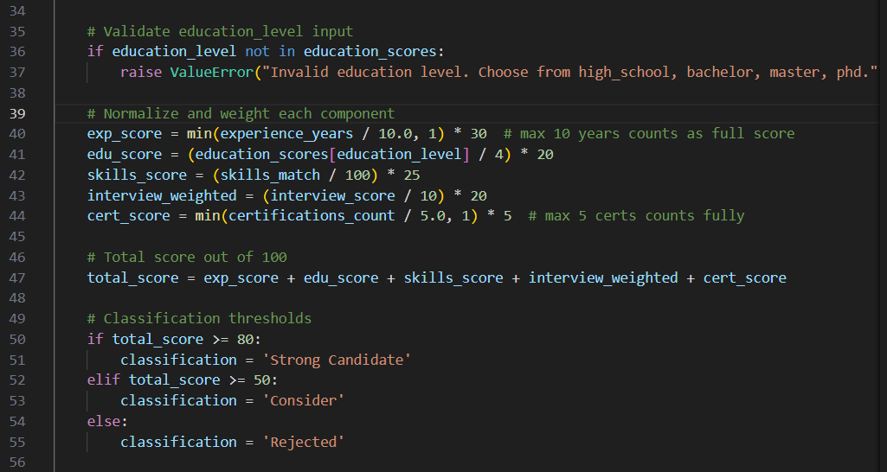

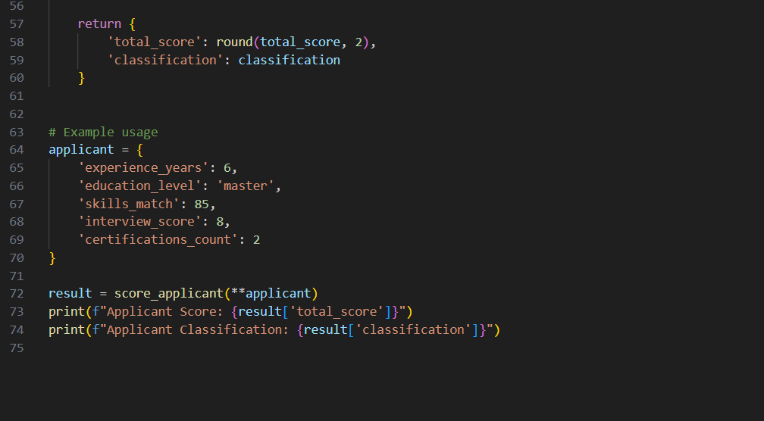

Expected Output: Python code
Analyze is there any bias with respect to gender or any
Practical Output:

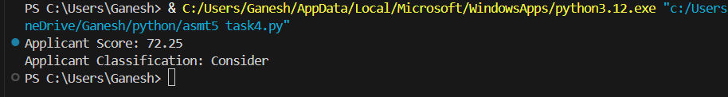

Task – 5
Description: Code Snippet
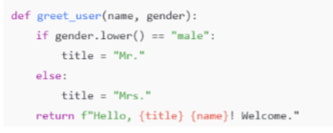

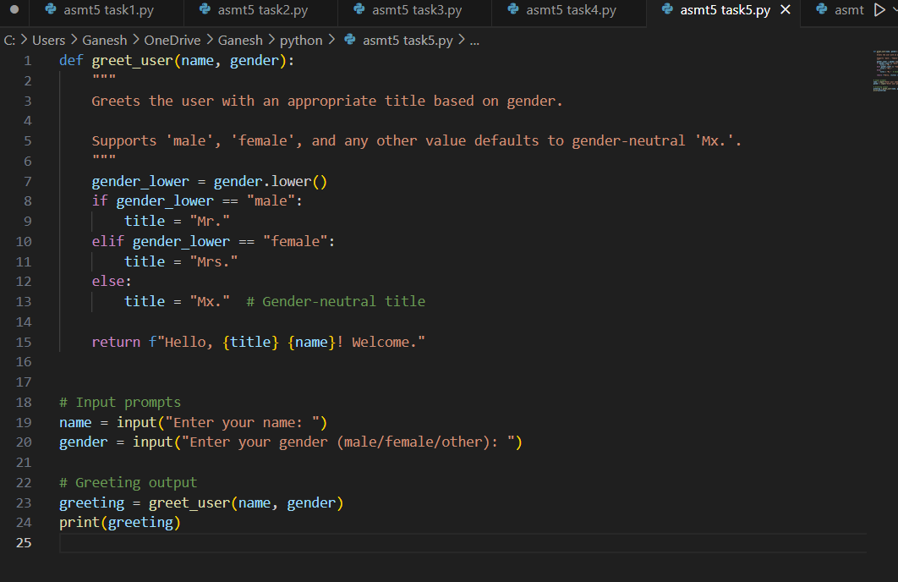

Expected Output: Regenerate code that includes gender-neutral also
Practical Output:

